District GIS Parakh – Asset Survey & Inspection Platform
Business Specification Document
Indore Commissioner & Collectorate Inspection Workflow | Web & Mobile

1. Purpose
This document defines the business requirements for extending the District GIS Parakh application (web and mobile) to support a hierarchical, department-wise inspection, monitoring, and action-tracking workflow for the Indore Commissioner and Collectorate structure. The objective is to move beyond a one-time inspection record and enable continuous tracking of follow-up action against every inspection, with visibility at the Department, Collectorate, and Divisional Commissioner levels.

2. Scope
- New login/role level for the Divisional Commissioner, positioned above the Collectorate.
- Department-wise and sub-department-wise user (inspector) management.
- A new Inspection Form with Department and Sub-Department drop-downs and a general checklist with an open remarks field.
- Automatic work allocation of inspection findings to the concerned Department Officer/HOD.
- Parallel, view-only visibility of inspection data to the District Collector and Divisional Commissioner.
- Action-tracking workflow with defined statuses and department-wise, officer-wise reporting with filters.
- Applies to both the Web Panel (primary reporting/monitoring) and the Mobile App (field inspection capture).

3. Organisational Hierarchy
The platform will reflect the following administrative hierarchy, with each level having a defined login and view scope:
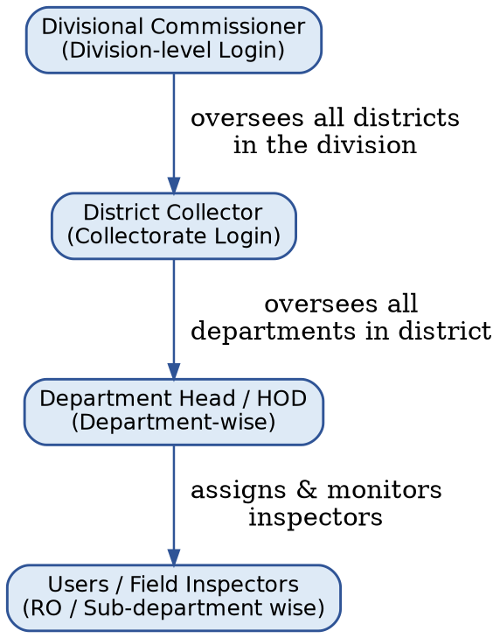
Level | Login / Role | Scope of Visibility
1 | Divisional Commissioner | All districts within the division (e.g., 5 districts under Indore division) – view only, dashboard/summary level
2 | District Collector | All departments within the district; monitors whether HODs are acting on recommendations within SLA
3 | Department Head (HOD) | Own department only; updates action taken, uploads evidence/letters
4 | Users / Field Inspectors (RO) | Assigned department/sub-department; conducts inspection and submits recommendations
Key Requirement: A Divisional Commissioner login is mandatory and must be inserted above the District Collectorate in the hierarchy. This is a new level in the system — currently the highest login is the Collector; the Commissioner level did not exist earlier and needs to be added on top of it.

4. User & Department Management

4.1 Add User
A new “Add User” form will capture the following, so that every user is mapped to a department for reporting and assignment:
- User Belongs To → Department Name (standard drop-down, master-driven).
- Sub-Department Name (standard drop-down, master-driven, dependent on Department).
- Department ID and Sub-Department ID (e.g., Dept 707, Sub-Dept 101) are used internally to route inspections and assignments.

4.2 User Screen (List / Search / Edit)
- User list and edit screen with department-wise and sub-department-wise filters.
- Search by Department, Sub-Department, User/Inspector name or ID.
- Each department will have its own set of Reporting Officers/Inspectors (RO) — across Indore Collectorate, approximately 56 ROs across departments are mapped at present.

4.3 User–Department Assignment Screen (Inspector Form)
A dedicated “User at Dept” screen maps each inspector to a department and sub-department, and assigns their reporting scope:
- Dept ID – drop-down/searchable field (e.g., Dept ID 707).
- Sub-Dept ID – drop-down/searchable field, dependent on the selected Dept ID (e.g., Sub-Dept ID 101, giving the combination 707-101).
- Assigned To – drop-down to select/edit the inspector assigned to that Department / Sub-Department.
- Submit button saves the mapping, after which the inspector appears in that department’s RO list.

5. Inspection Form (Web & Mobile)
A new Inspection Form will be added with the following behaviour, applicable identically on web and mobile:
- Inspector selects Department and Sub-Department from drop-downs (mandatory).
- A common General Checklist is used across departments (department-specific checklists will be phased in later without blocking rollout).
- An Open Remarks field allows the inspector to record free-form recommendations, categorised broadly as Developmental (e.g., infrastructure gaps) or Disciplinary (departmental action against an officer).
- On submission, the finding is auto-assigned to the concerned Department Officer/HOD for action, and simultaneously made visible (read-only) to the District Collector and Divisional Commissioner.

6. Assignment & Action-Tracking Workflow
Every submitted inspection finding is auto-routed for action and tracked to closure as shown below:

6.1 Action View Page (New)
- Assigned Officer/HOD sees the finding with an Action Remark text box and evidence/letter upload.
- On submit, status moves to one of: Pending, Closed, or Unapproved / Rejected.
- Collector monitors SLA — whether the department is acting within the expected timeframe; Divisional Commissioner sees summary status only.

7. Reporting & Dashboard
- Department-wise report with columns for Department and Sub-Department, filterable at report level.
- Collector-level filter: select a specific department and view which inspectors/ROs under that department have completed inspections.
- Divisional Commissioner view: division-wide summary across all districts — total inspections, action-taken (Completed), and Pending count per district.
- Status dashboard clearly separating Pending vs Completed vs Rejected cases.

7.1 Department View Screen – Collector Login / Division Login
A common “View” screen is accessible from both the Collector Login and the Division(al) Login (toggle between the two), listing all Reporting Officers (RO) department-wise:
- Screen displays the list of RO’s of Dept — one row per department, showing its assigned Reporting Officer(s).
- Collector Login shows this list scoped to the district; Division Login shows the same structure rolled up across the districts in the division.

8. Key Business Rules
- Every user/inspector must be mapped to exactly one Department and Sub-Department before they can log an inspection.
- Inspection data flows in parallel to the Department HOD and the District Collector — neither is blocked waiting on the other.
- The Divisional Commissioner login is read-only / dashboard-level and sits above the Collectorate in the access hierarchy.
- Rollout will not wait for department-specific checklists; a general checklist with open remarks is used from day one, with department-specific checklists added iteratively.
- Mobile app is used primarily for inspection capture; web panel is the primary interface for monitoring, assignment, and reporting.

9. Development / Build Checklist (Sequence)
The build will be delivered in the following sequence:
- User Screen.
- Edit User Screen & View (List).
- Add Filters & Department-wise User List / Search.
- New Form of Inspection – with drop-down of Department & Sub-Department.
- Report – with Department-wise Search and columns for Department & Sub-Department.
- Assign to the respective officers & Work Allocation (Auto).
- New View Page for the assignment – Action Remark box and Action button, moving status to Pending / Closed / Unapproved-Rejected.

10. Next Steps
- Finalise and configure Department and Sub-Department master data (including existing 56 RO mappings).
- Build the Divisional Commissioner login/tab, positioned above the Collectorate, with district roll-up view.
- Develop the new Inspection Form (mobile + web) with department/sub-department drop-downs and general checklist.
- Implement auto-assignment to HOD and the Action View page with status workflow.
- Enable department-wise and officer-wise filtered reporting with the Pending/Completed status dashboard.
Prepared for: District GIS Parakh – MPSeDC / MPSSDI | Indore Commissioner & Collectorate Rollout

